**HW4, ML in Healthcare – 336546**

Edited by **Hadas Ben-Atya & Nathan Berdugo**

**Task 1:**

***Task 2:*** *Activation functions.*

Change the activation functions to LeakyRelu or tanh or sigmoid. Name the new model new_a_model. Explain how it can affect the model.*

We changed the activation function to Leaky- ReLU:

$$LRelu= \left\{\begin{aligned}x ; if x>0 \\ α*x; if x<0\end{aligned}\right.$$

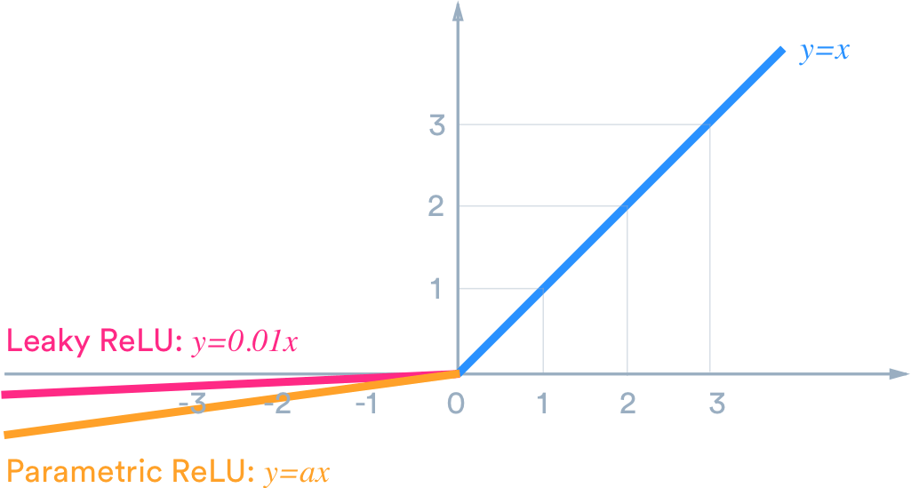

This change will affect the model's non-linearity method.

The Leaky ReLU has some benefits over the ReLU[1]:

1. It does not have a zero-slope parts.
2. It speeds up the training because unlike ReLU, leaky ReLU is more “balanced,” and may therefore learn faster.

***Task 3:*** *Number of epochs.*

Train the new model using 25 and 40 epochs. What difference does it makes in term of performance? Remember to save the compiled model for having initialized weights for every run as we did in tutorial 12. Evaluate each trained model on the test set

When the number of epochs is more than the necessary, the model will learn patterns that are specific to the training dataset, and we may reach an **overfitted model**. This model, then, will become incapable to perform well on new set of data (the test dataset in our case) – the accuracy on the training data will be high but the accuracy for the testing data will be low, and will imply for a poor performance**[2]**.

On the other hand, too small number of epochs will cause **underfitting**; the model will not learn enough features before the end of the training, and our results will be poor for both the training and testing data.

As a result, the model should be trained for an optimal number of epochs. Regarding our model, one can notice that the model which was trained with 25 epochs achieved better accuracy score than the model with 40 epochs. So, we conclude that in our case, 25 is indeed the optimal number of epochs needed, while by using 40 epochs we reach **overfitting** and poor performance.

***Task 4.1:*** *Mini-batches.*

Build the model_relu again and run it with a batch size of 32 instead of 64. What are the advantages of the mini-batch vs. SGD?*

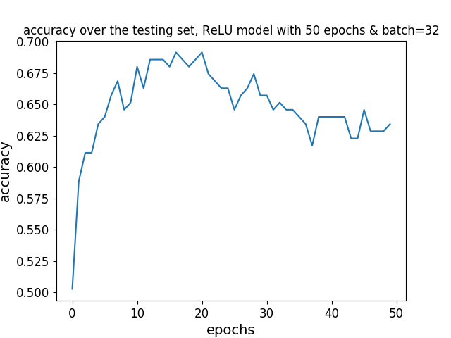

By using batches, we use a fixed number of examples in each epoch. The batch size can, therefore, control the accuracy of our model. A higher batch size will lead to a bigger difference between features' weights of the previous epoch. This may lead to an unstable performance and to low accuracy of our model. Having said that, by averaging the gradient of the fixed number of examples (i.e., the batch size), one can reduce the noise of its data.

A too small sized batch will lead to ***a slower model*** and cost us much more time. Moreover, we will not be able to properly ***reduce the noise*** in our data, thus by choosing a small-sized batch, one should consider the quality of its data first. This might happen when using mini-batch.

Regarding **SGD**, In this model we take the mini-batch to the extremity by practically choosing the batch size to be 1. The model will update the features' weights after (only) one example in each epoch. Thus, the step size will be moderate, but **the noise will not be reduced**.

***Task 4.2:*** *Batch normalization.*

Build the new_a_model again and add batch normalization layers. How does it impact your results?*

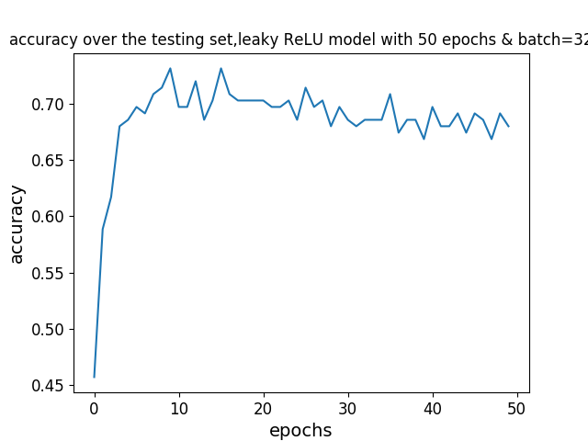

Batch normalization means that the input layer is normalized (i.e. re-centered and re-scaled[3]). Once the input is *normalized*, it is *standardized* to the mean of 0 (zero), and STD of 1. **By using batch normalization, we optimize the NN**: The model will now run faster, because of achieving convergence quicker. Thus, by using this method, one could be satisfied with smaller epoch size and reach the same accuracy or even better. Moreover, batch normalization will allow higher learning rates without risking too high fluctuations, benefiting the speed of the process as well.

In our results, we got a higher accuracy (0.68) after applying batch normalization, compared to the previous, un-normalized models (0.657). The result conforms with our expectations as explained above.

**Part 2 :**

***Task 1:*** *2D CNN.*

*Have a look at the model below and answer the following:*

* *How many layers does it have?*  
    
  The model has 8 (hidden) layers:  
   - Convolutional 2D layers (5)  
   - Fully-connected Dense layers (3)  
    
  Note that other processing operations might be included in each hidden layer, such as *BatchNormalization*, *MaxPooling*, *Dropout* etc.
* *How many filters in each layer?*  
    
  In each of the five convolutional 2D layer, the number of filters is (respectively): [64, 128, 128, 256, 256]
* *Would the number of parameters be similar to a fully connected NN?*  
    
  No, the number of parameters will not be similar to a fully connected NN. In our 2D CNN, we use filters and *MaxPooling* processing, which decrease the number of parameters our model uses.
* *Is this specific NN performing regularization?*  
  Yes, this specific NN do perform regularization. Each convolutional 2D layer include a regularization kernel (L2, specifically).

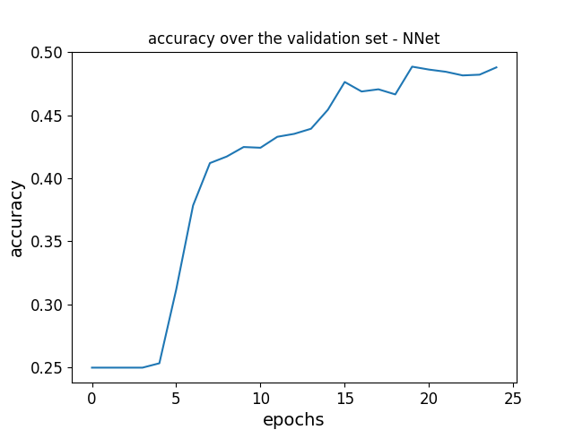

***Task 2:*** *Number of filters*

Rebuild the function get_net to have as an input argument a list of number of filters in each layers, i.e. for the CNN defined above the input should have been [64, 128, 128, 256, 256]. Now train the model with the number of filters reduced by half. What were the results.

Tests results :

|  |  |  |
| --- | --- | --- |
| acc | loss | model |
| 0.668 | 0.845 | ReLU model, batch = 64 |
| 0.6629 | 0.809 | New model, 25 epochs |
| 0.657 | 0.809 | New model, 40 epochs |
| 0.63 | 0.866 | ReLU model, batch = 32 |
| 0.68 | 0.908 | New model, batch norm |
| 0.342 | 7.9 | NNet model |
| 0.257 | 4.869 | NNet reduced filters |

*References:*

[1] <https://medium.com/@danqing/a-practical-guide-to-relu-b83ca804f1f7>

[2] <https://www.geeksforgeeks.org/choose-optimal-number-of-epochs-to-train-a-neural-network-in-keras/>

[3] Jaron Collis, Glossary of Deep Learning: Batch Normalization; <https://medium.com/deeper-learning/glossary-of-deep-learning-batch-normalisation-8266dcd2fa82>